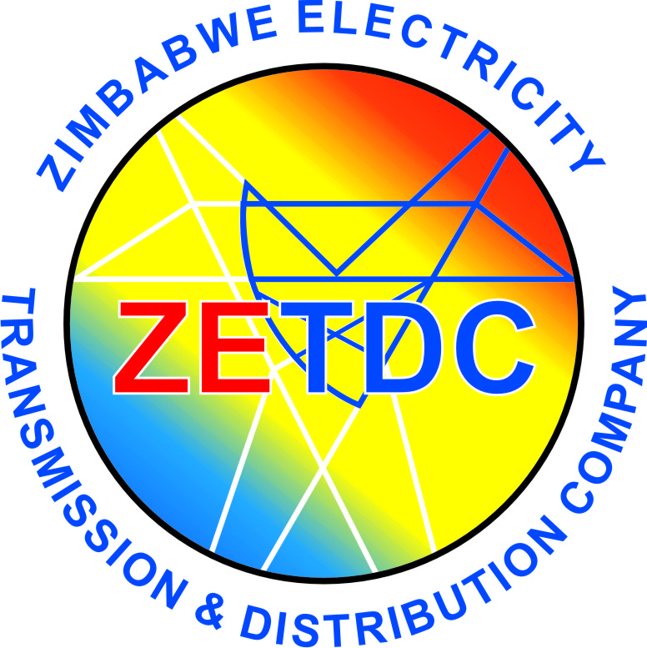
ZIMBABWE ELECTRICITY TRANSMISSION
& DISTRIBUTION COMPANY
HARARE REGION
ELECTRICITY CENTRE,
Cnr WYNNE STREET/ROBSON MANYIKA
HARARE
P.O. BOX 73, HARARE

TELEPHONE: 706451/5, 792861/9

OUR REF:… ……………………………………

YOUR REF ……………………………………

WHEN CALLING WITH REFERENCE
TO THIS LETTER PLEASE ASK FOR

……………………………………..

Introduction

This agreement is made and entered into as of Tuesday 5 March 2024 by and between:

ZIMBABWE ELECTRICITY TRANSMISSION & DISTRIBUTION COMPANY, a corporation located at Cnr WYNNE STREET, HARARE.
KWARAMBA ANDY TATENDA, a sole proprietorship located at 10603 SAVE CRESCENT BUDIRIRO 5A, Harare Zimbabwe.

Background

You are developing a load-shedding mobile application called ZETDC LOADSHEDDING that provides information and functionalities related to load shedding.
The licensor owns certain intellectual property rights that we wish to use in the Load-shedding App and/or its store listing.

Grant of License

In consideration of the mutual covenants contained herein, ZETDC hereby grants to KWARAMBA ANDY TATEND a non-exclusive, worldwide, royalty-free right and license to use, reproduce, modify, adapt, publish, distribute, and display the Licensed IP in connection with the App and its store listing, solely to provide load shedding information and functionalities to users.
The "Licensed IP" includes:
- Brand name ZETDC.
- Logo ZETDC.
- ZETDC Load Shedding Schedules.

Term and Termination

This Agreement shall commence on the effective date and shall continue for a period of one year, unless earlier terminated as provided herein.
This Agreement may be terminated by either party upon 10days' written notice to the other party, specifying the reason for termination.
This Agreement shall automatically terminate upon the occurrence of any of the following events:
- You breach any material provision of this Agreement and fail to cure such breach within 14 days after written notice from Licensor.
- You become insolvent or bankrupt.

Representations and Warranties

You represent and warrant that KWARAMBA ANDY TATENDA has the full right, power, and authority to enter into this Agreement and to perform your obligations hereunder.
ZETDC represents and warrants that it has the full right, power, and authority to grant the licenses set forth herein.

Indemnification

You agree to indemnify, defend, and hold harmless the Licensor, its officers, directors, employees, agents, and affiliates, from and against any and all claims, losses, damages, liabilities, costs, and expenses (including reasonable attorneys' fees) arising out of or relating to your use of the Licensed IP, your breach of this Agreement, or your violation of any applicable laws or regulations.

Entire Agreement

This Agreement constitutes the entire agreement between the parties with respect to the subject matter hereof and supersedes all prior or contemporaneous communications, representations, or agreements, whether oral or written.

Severability

If any provision of this Agreement is held to be invalid or unenforceable, such provision shall be struck and the remaining provisions shall remain in full force and effect.

Notices

All notices and other communications hereunder shall be in writing and shall be deemed to have been duly given when delivered personally, sent by certified or registered mail, return receipt requested, postage prepaid, or sent by overnight courier, addressed as follows:

KWARAMBA ANDY TATENDA: 10603 Save Crescent, Budiriro 5A, Harare
ZETDC: Cnr WYNNE STREET, Harare

Waiver

No waiver by either party of any breach or default hereunder shall be deemed to be a waiver of any subsequent breach or default.

Counterparts

This Agreement may be executed in one or more counterparts, each of which shall be deemed an original, but all of which together shall constitute the same instrument.

IN WITNESS WHEREOF, the parties have executed this Agreement as of the date first written above.

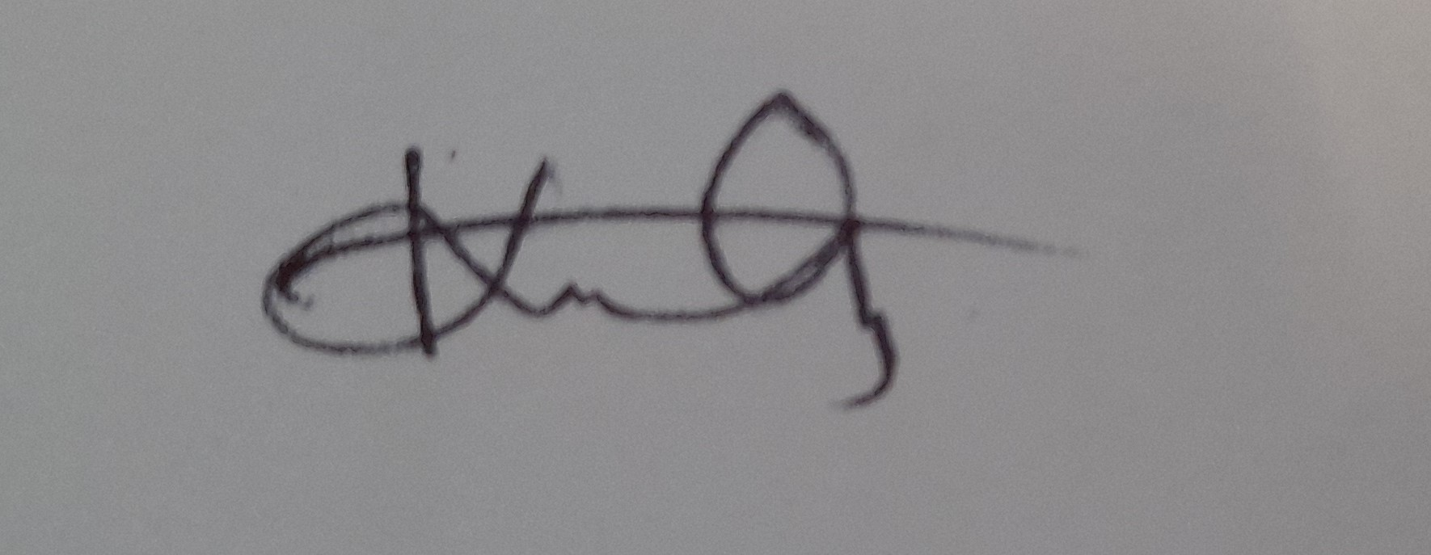
KWARAMBA ANDY TATENDA

[Licensor Signature]

ZETDC

